I wrote this up in the best way I felt it would help you…I am open to your advice and expertise.

Much of this describes how my business works/flow now.

Purpose of TechScreen application: I provide a service to recruiting firms to technically question and recommend job candidates to a company for hire. The way it works is that a recruiting firm hires my company. The recruiting firm is the top level client. We will say ABC recruiting for this example. ABC recruiting (top level client) has clients that they recruit for, these are the ‘clients). So to continue the example, ABC recruiting has two clients, American Steel, Inc and St James Hospital (these are the clients). The recruiters work for the top level client. It is there job to find people to work in the ‘clients’ companies. For example Jeff is a recruiter. He works for ABC recruiting. His boss comes to him and says, “Jeff, we need you to find a .net developer to work in American Steel, Inc.” Jeff then goes to the online job sites, etc and looks for a person to work in American Steel as a .net developer. He finds a resume for a person named Andrew. He finds he is qualified and talks to him, etc. Andrew is the candidate. Some companies such as Amercian Steel, Inc don’t have time to interview various candidates. They would like ABC recruiting to decide the candidates are qualified for the position. That’s where my company comes in. Once Jeff feels that Andrew is a good fit, he will request a technical screening. This is where a senior technical person will meet with Andrew and ask him questions which are appropriate to the skill level of the position (junior, senior, etc). Lets say that Ravi is a technical expert, he has been a developer for 15 years and is certified in many technologies (.net, Java, etc).

Before Jeff can request a technical screening, he must create a position in the application (that is the .net developer job to be filled) and also a candidate record in the application (and upload his resume for Ravi’s review).

Once those two things are created in the application, he will request a technical screening. The screening is the appointment for Ravi and Andrew to meet and ask the questions, etc.

The flow of this is that he will create a new screening appointment. A screening is generally 30 mins and should default the end time to 30 mins after the start time is selected, but can be changed, if needed. This request will somehow notify the admin that there is a new screening apt requested. The screening will be in ‘requested’ status (screeningStatus table). The admin will go in and see the screener with the skill set and see if/when they are avail for screenings. (via phone call to screener and/recruiter, sometimes this takes some back and forth). The admin needs the ability to change the day/time of the screening request. Once the appointment is agreed upon, the admin will assign the screening to the screener. The screener will see it in ‘screenings pending appointment confirmation’. He will then confirm or decline. Once the screener confirms or declines, the admin will get notified. The admin will go in and see a list of confirmed appointment (may need additional screening status for this). And click ‘create appointment’ This is the part where a standard calendar appointment is downloaded to the admins computer and creates an email (with appointment and prepopulated emails addresses in the ‘To’ and subject) to be send by the admin to the screener and recruiter. We may want an option if we also want the candidates email populated or not, some recuiters prefer to contact the candidate them selves, some do not.

Ravi will review Andrews resume and the job req (job requirement).

The questions area is a part I am still having trouble figuring out…so I am open to your advice on this.

He will pull the questions from the application which are listed under this specific skill and skill level. However, in some cases these questions are not appropriate and he needs to write his own questions which will be added to the screening appointment. Ravi will add those questions to the application in the screening details. The questions that are avail for all screeners (somewhat standard questions) are only added by the admin. However, since the screener can add his own questions those are only avail for that screening and will not be added in the standard questions list (unless he emails the admin and asks him to add them).

During the screening the screener will ask questions. (this is mostly the ScreeningQA table). This will be part of the screening details, which questions are asked. For example, Ravi chooses 5 standard questions from the application but has 3 of his own. He needs to show that all 8 questions were asked (with the question text) and provide the answers from the candidate. Also, an ‘answered correctly’ choice is avail (answerStatus table). The final step will be to check ‘recommended’ yes/no this is where the determines if this candidate should be placed in the position.

The other side is this, is payment. I don’t expect there to be any payment info etc. But I want you to understand how it works so you can see where/why we need it tracked.

I get paid by the top level clients. I need to email them reports. These are the results of screenings done in a time frame. Generally ever week, but the date range needs to be able to change. For example, send a report to ABC recruiters with all the screening that were done by Everconnect for the period of 7/1/13 to 7/21/13, grouped by clients (so they can bill their clients). However, we also need to be able to send top level client a report that is the same but for only 1 or more of their clients. For example, they need to bill their 1 client and don’t want to see the others. Or if I need to send the report to only 1 recruiter, I need to also filter on recruiter. So basically, when creating the report to be emailed, I would say give me all screenings for this top level client, where between these dates, (either all clients) or clients included, and (either all recruiters) or recruiters included group by client.

In addition we need to send an email to all the screeners to show they have credit for their screenings and will get paid for these. They only get credit if they complete a screening. We generally, go off of the fact that they choose ‘recommeded yes/no’ in the app to give them credit.

This can be one report, query for all screeners (for a date range).

Something like this in a professional styled email (html and plain txt).

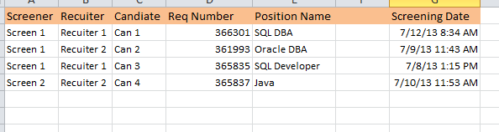

The site looks good so far. I like the layout and style you have chosen. ☺

The admin looks good and the management menu and options for the admin (role) looks good.

However, the screener and recruiter roles will not need a management. If you look at my wireframes, you will see that the screener will not create skills, clients etc (that’s for the admin).

He will create a candidate, position and screening appointment. He will also, view HIS candidates, positions and screening appointments.

Maybe create a new menu for ‘screener’ and new menu for ‘recuiter’ and make these only avail to the appropriate roles (and admin and management avail to admin)…something like that. ☺

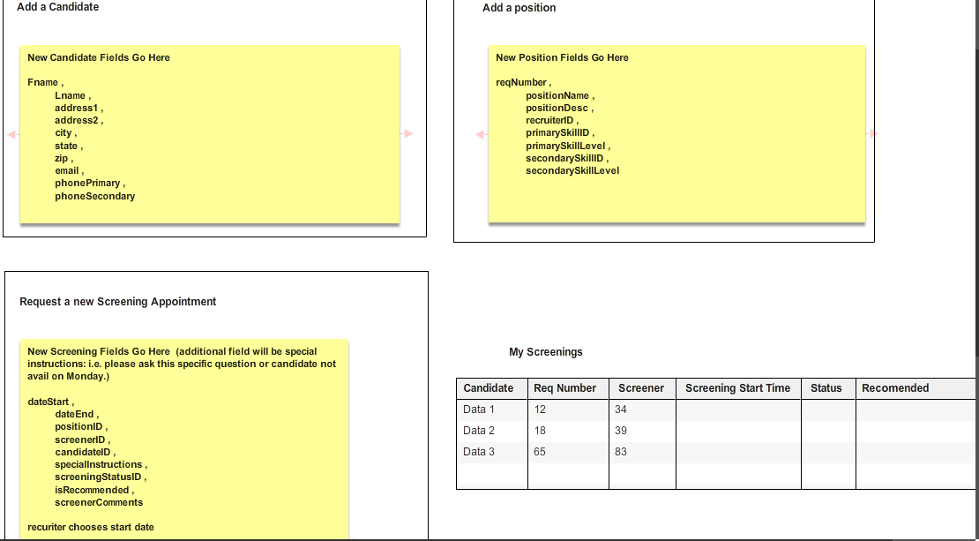

The screener will see his pending screenings as well as his screenings.

Also, when he chooses start or edit (for a screening he will be taken to a edit screening, where he will edit the details, review resume, add questions, etc.)

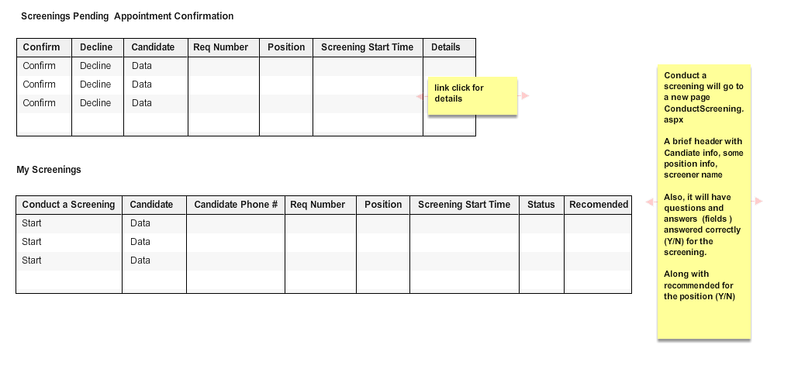

As a rule, in dropdown lists etc, recruiters can only see info for their toplevel client, and clients. Not for other top level clients. For example when a recruiter is creating a screening appointment we don’t want him to see or have the ability to see a client that belong to another top level client (from dropdown list, etc).

Screeners can only see their own screenings. The admin will assign a screening to a screener and change it, if needed.

Also, only active users will show up in dropdown lists for assigning, etc. No inactive users should show up in the list to assign screening to a screener, etc. Inactive recruiters should not show up in reports.

Hopefully, this helps…let me know if you have further questions.